**How to Use Template**

**Fanstrap Bootstrap Anime Blogger Template**

**Edit Meta Tag Author**

1. Go to Blogger.com log in your account blog
2. Your Blog > Template > Edit Html
3. Find (CTRL + F)

<link href='https://plus.google.com/XXXX/posts' rel='publisher'/>

<link href='https://plus.google.com/XXXX/about' rel='author'/>

<link href='https://plus.google.com/XXXX' rel='me'/>

Change **XXX** with your ID Google Profile

**Edit Author Blog**

<meta content=**'XXXX'** name='author'/>

**Edit Keyword in Homepage**

<meta content=**'XXXX'** name='description'/>

<meta content=**'XXXX'** name='keywords'/>

**TIPS SEO**

1. Find and Delete this below Html

<b:include name='quickedit'/>

2. add ALT and Title in your Images

<imgsrc=**’exampleurlimage’** alt=’post title’ title=’post title’ />

**TIPS SEO in Widget Title**

1. Find this below (in widget)

**<h2><data:title/></h2>**

And replace with this code

**<h3><data:title/></h3>**

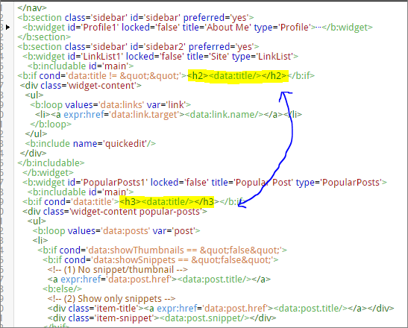

**Disable Custom Mobile**

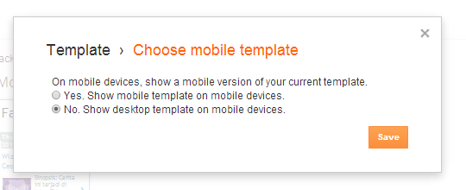

**Menu Dropdown**

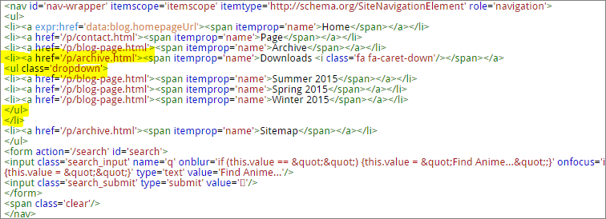

<ul> and </ul> This a dropdown code

**Slider Anime**

**NOTE : HEIGHT AND WIDTH SLIDER ANIME IS**

**WIDTH = 690PX and HEIGHT = 350PX**

<div class='carousel slide' data-ride='carousel' id='carousel-generic'>

<!-- Indicators -->

<ol class='carousel-indicators'>

<li class='active' data-slide-to='0' data-target='#carousel-generic'/>

<li data-slide-to='1' data-target='#carousel-generic'/>

<li data-slide-to='2' data-target='#carousel-generic'/>

</ol>

<!-- Wrapper for slides -->

<div class='carousel-inner' role='listbox'>

<div class='item active'>

<img alt='Musaigen no Phantom World' src='http://1.bp.blogspot.com/-mjoBTl5gbwQ/VqHK6fEArWI/AAAAAAAAE9U/oM_5S779blc/w690-h350-c/slider_4.jpg'/>

<div class='carousel-caption'>

<h3>Musaigen no Phantom World</h3>

<p>In the near future, spirits and monsters are in full sight.</p>

</div>

</div>

<div class='item'>

<img alt='Durarara!!×2 Ketsu' src='http://1.bp.blogspot.com/-tJNhpAZn0KI/VqHKtU4r-xI/AAAAAAAAE88/D0UHhW8XlLA/w690-h350-c/slider_2.jpg'/>

<div class='carousel-caption'>

<h3>Durarara!!&#215;2 Ketsu</h3>

<p>Final cour of &quot;Durarara!!&#215;2.&quot;</p>

</div>

</div>

<div class='item'>

<img alt='Akagami no Shirayuki-hime 2nd Season' src='http://3.bp.blogspot.com/-amvlA0yscJY/VqHK8LJrKhI/AAAAAAAAE9c/qK7ajeFZHGI/w690-h350-c/slider_5.jpg'/>

<div class='carousel-caption'>

<h3>Akagami no Shirayuki-hime 2nd Season</h3>

<p>In the kingdom of Tanbarun lives Shirayuki, an independent and strong-willed young woman.</p>

</div>

</div>

</div>

<!-- Controls -->

<a class='left carousel-control' data-slide='prev' href='#carousel-generic' role='button'>

<span aria-hidden='true' class='glyphicon glyphicon-chevron-left'/>

<span class='sr-only'>Previous</span>

</a>

<a class='right carousel-control' data-slide='next' href='#carousel-generic' role='button'>

<span aria-hidden='true' class='glyphicon glyphicon-chevron-right'/>

<span class='sr-only'>Next</span>

</a>

</div>

**Add Responsive for Popular Post**

1. Go to Blogger.com log in your account blog
2. Your Blog > Template > Edit Html
3. Find (CTRL + F) <div class='widget-content popular-posts'>

Example :

<div class='widget-content popular-posts'>

<ul>

<b:loop values='data:posts' var='post'>

<li>

*…………….. bla bla bla bla*

1. You see <li> after html <div class='widget-content popular-posts'>
2. Then add class='col-xs-6 col-sm-12 col-md-12' in <li>

Example :

<div class='widget-content popular-posts'>

<ul>

<b:loop values='data:posts' var='post'>

<li class='col-xs-6 col-sm-12 col-md-12'>

**SEO for Widget Popular Posts**

1. Go to Blogger.com log in your account blog
2. Your Blog > Template > Edit Html

Find (CTRL + F) <div class='item-thumbnail'>

Example :

<div class='item-thumbnail'>

<a expr:href='data:post.href' target='_blank'>

<img expr:height='data:thumbnailSize' expr:src='data:post.thumbnail' expr:title='data:post.title' expr:width='data:thumbnailSize'/>

</a>

</div>

1. Then replace with this html

<div class='item-thumbnail'>

<a expr:href='data:post.href' target='_blank'>

<img expr:alt='data:post.title' expr:height='data:thumbnailSize' expr:src='data:post.thumbnail' expr:title='data:post.title' expr:width='data:thumbnailSize'/>

</a>

</div>

**Add Icon in Widget**

1. Go to Blogger.com log in your account blog
2. Your Blog > Template > Edit Html
3. Find (CTRL + F) <b:if cond='data:title != &quot;&quot;'>

Example :

<b:if cond='data:title != &quot;&quot;'>

<h2 class='title'><data:title/></h2>

</b:if>

1. Then add icon <i class=’glyphicon glyphicon-heart’/> <- example

<b:if cond='data:title != &quot;&quot;'>

<h2 class='title'><i class=’glyphicon glyphicon-heart’/><data:title/></h2>

</b:if>

Get Icon from [Here!!](http://getbootstrap.com/components/#glyphicons)

Thanks for

* Google Translate
* Konachan for Header Image
* DTE for Tips & Trick Blogger
* Arlina for Related Post
* Bootstrap for Framework
* Blog Kangismet for HTML WIDGET CONTACT FORM IN STATIC PAGE
* Etc ._.